# Admin Layout Changes

This document reviews the layout changes/fixes for the admin view.   
 **Carriers –** This page is good.

**Document Mgmtg –** Everything looks perfect on the document exporting on admin view except for the sorting.

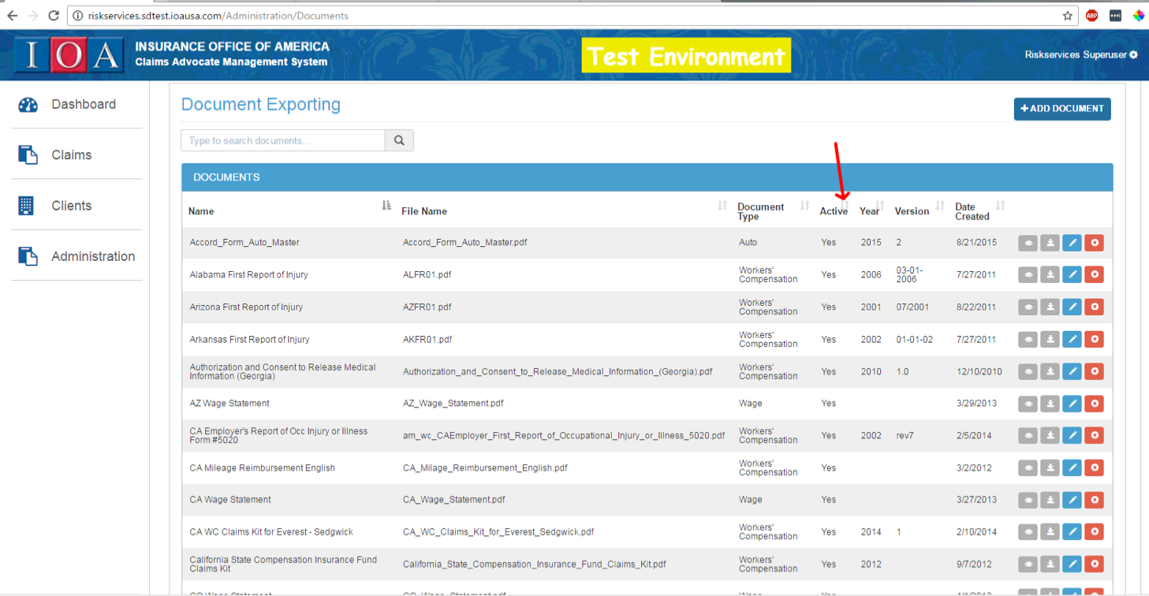

**Loss Run Import** – This page table just needs to be styled like the others.

**Clients –** Client tabs needs to be styled similar to producer/client-search.html.